## Lab # 2: Introduction to MS Access (Queries, Forms, Reports)

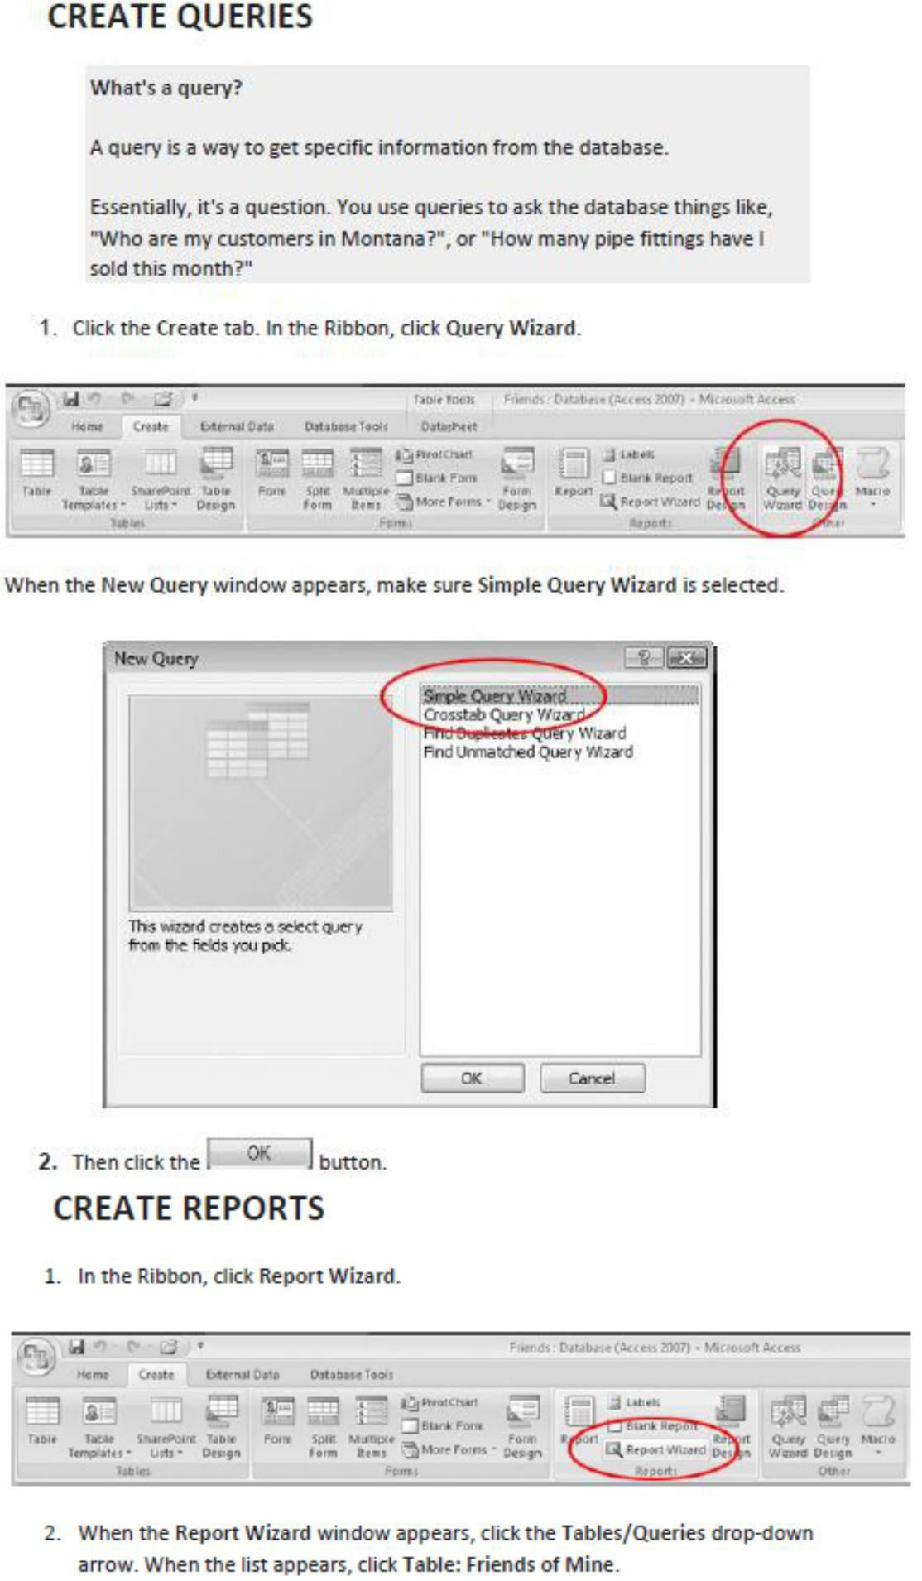

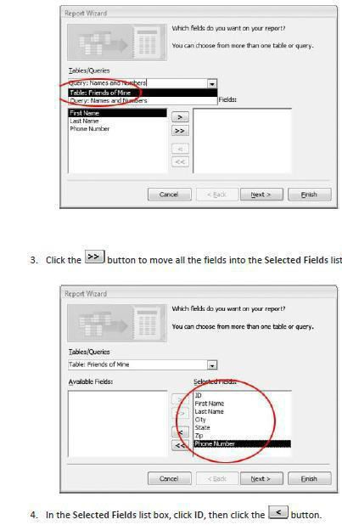

CS203 Database Systems Lab Manual

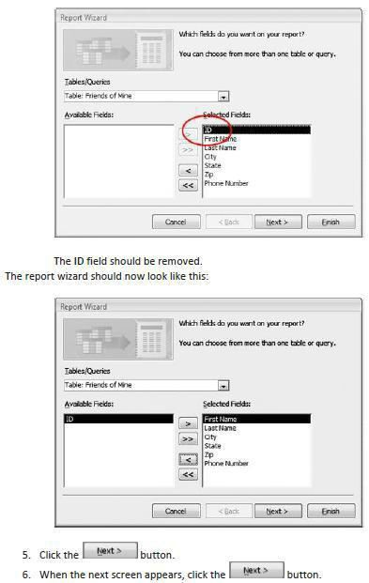

CS203 Database Systems Lab Manual

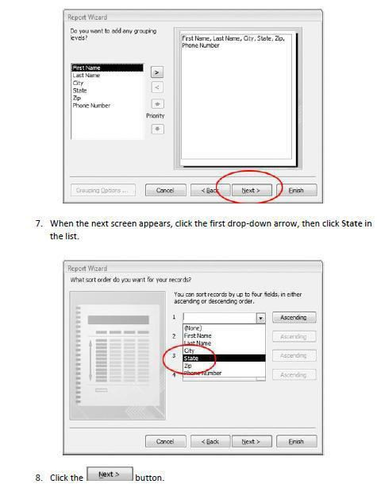

CS203 Database Systems Lab Manual

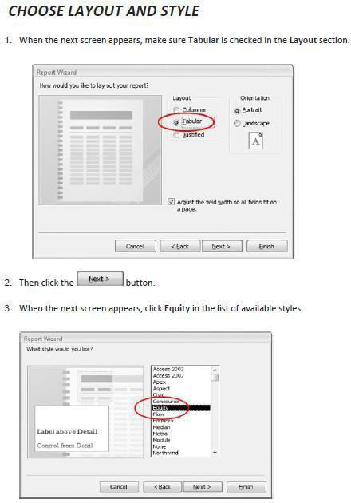

CS203 Database Systems Lab Manual

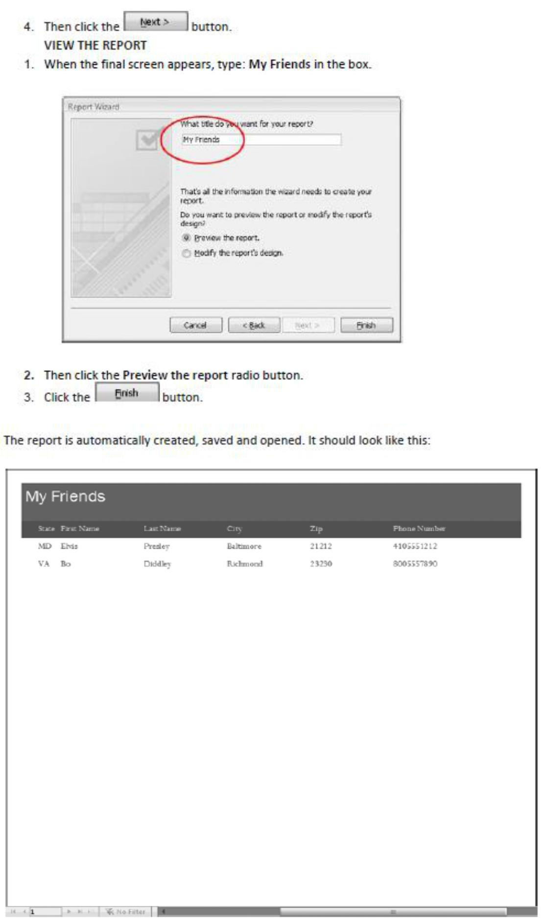

CS203 Database Systems Lab Manual